
School of Science and Technology

Electronic Devices and Materials Technology ENGG10031
Academic Year 2022-2023

Lab 8: MOSFET – Characteristics and applications

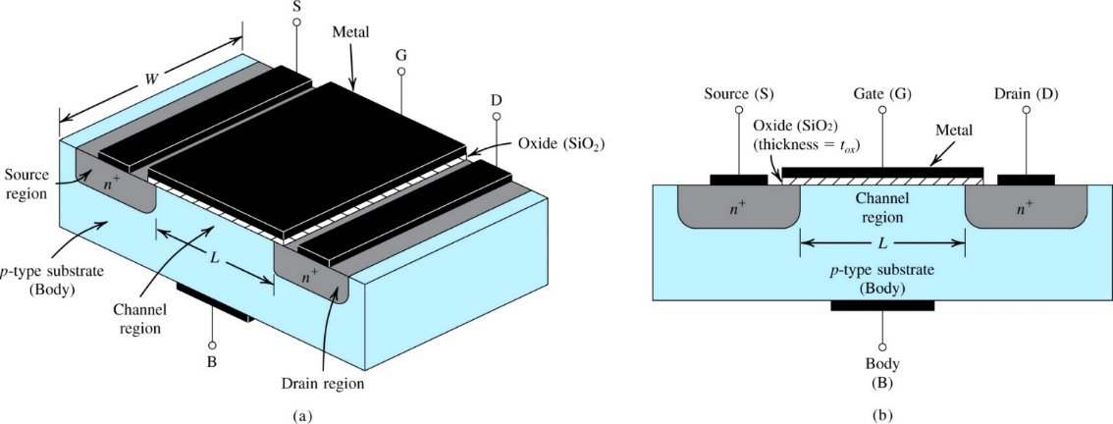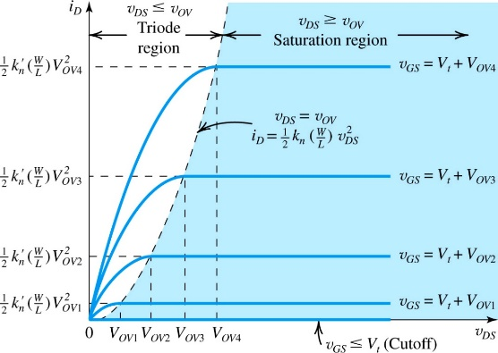

Objectives
- Studying transfer and output characteristics of MOSFETS
- Using MOSFET as a switch

Equipment and components:
- MOSFET 2N7000
- Breadboard
- resistor (1kΩ, 100kΩ, 560Ω)
- DC power supply
- Digital mustimeters (DMM) × 3
- LED (L-53YD)
- Signal generator
- connecting wires

Required information

Introduction to the MOSFET
The MOS(metal-oxide-semiconductor) transistor (or MOSFET) is the basic building block of most computer chips, as well as of chips that include analog and digital circuits. In this lab, you will work with what is called an n-channel MOS transistor.
A common symbol for the N-channel MOS transistor is shown in Figure 1(a). Of the terminals shown, the ones we will focus on are the source, drain, and the gate. In the transistor we will be working with in this lab, the fourth terminal, labelled body in Figure 1(a), is not accessible externally; rather, it is internally connected to the source, as shown by the broken line. For simplicity, we will use the symbol shown in Figure 1(b).
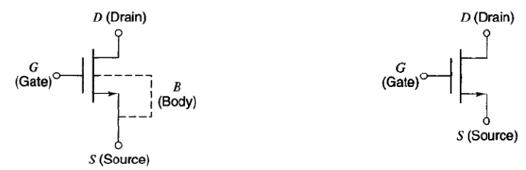
(a) (b)
Figure 1 MOSFET
To study the MOSFET, two external voltage sources are required, as shown in Figure 2. These provide the drain-source voltage V_{DS} and the gate-source voltage V_{GS}. The voltage V_{DS} may cause a drain-to-source current i_{D} as shown, provided that there is a path for this current from the drain through the device to the source. Whether such a path exists or not depends on the value of V_{GS}. For small values of V_{GS}, no such path is established within the device, and i_{DS} is zero. The device then looks like an open circuit between the drain and the source. For a sufficiently high V_{GS}, an internal current path, called a channel, is established between the drain and the source. Now a current can flow. The precise value of V_{GS} determines how easy it is for the channel to conduct the current; the higher the value V_{GS}, the easier such conduction is and the larger the value of i_{DS}. For a given V_{GS}, the value of i_{DS} will also depend on V_{DS} and will tend to increase with the latter.

Transfer and output characteristics of a MOSFET
In this experiment, you will observe the transfer and output characteristics of an NMOS transistor. Transfer characteristics features the dependency of the drain current on gate voltage. The simplified reference circuit for this experiment and the expected response is shown in Figure 2.
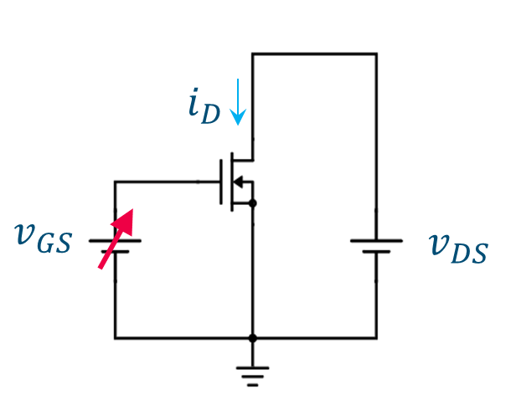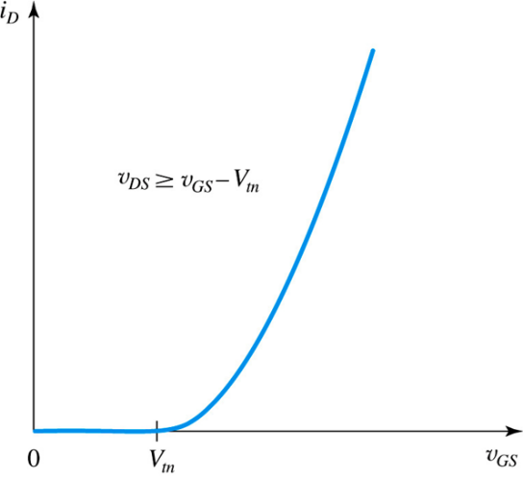
Figure 2. The reference circuit and transfer characteristics of a MOSFET
The output characteristics illustrate the dependency of the drain current on drain voltage. Since this depends on the gate voltage, we can obtain a family of graphs. Figure 3 shows the simplified reference circuit for this experiment and the expected family of curves.

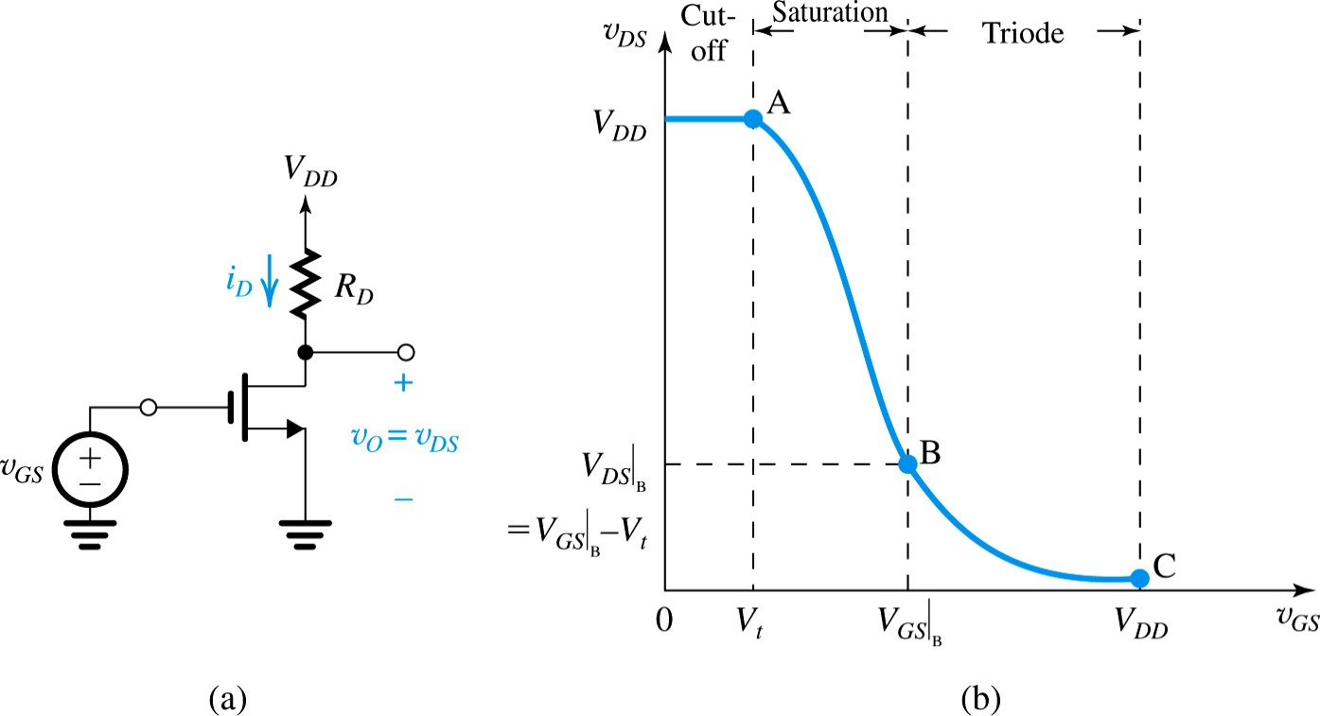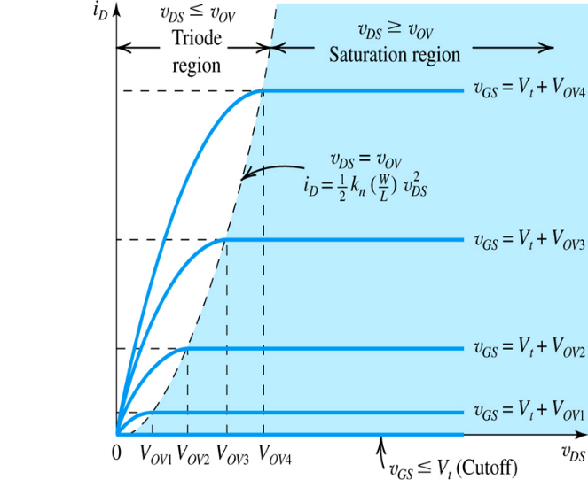
Figure 3. The reference circuit and output characteristics of a MOSFET

Definitions of terms:
  - Threshold voltage V_{T}: Gate to source voltage at which, drain current starts flowing.
  - Transconductance g_{m}: Ratio of small change in drain current (ΔI_{D}) to the corresponding change in gate to source voltage (ΔV_{GS}) for a constant V_{DS}.
  - g_{m} = ΔI_{D}/ΔV_{GS} at constant V_{DS}
  - Output drain resistance: It is given by the ratio of small change in drain to source voltage (ΔV_{DS}) to the corresponding change in drain current (ΔI_{D}) for a constant V_{GS}.
  - r_{d} or r_{o} = ΔV_{DS} / ΔI_{D} at a constant V_{GS}

MOSFET as a switch
When a MOSFET is operated under cut-off regions ($v_{GS}≤V_{t}$), it can block the drain current due to very high resistance between the drain and source. On the other hand, when it is operated in the triode region ($v_{DS}≤V_{OV}$), the conductivity between gate and source becomes high due to the formation of induced channel. Hence, MOSFET facilitates the current flow and impose only a little voltage drop. Therefore, the aforementioned two states of MOSFET transistors are perfect for switching applications since the power loss within the transistor is minimal. The CMOS family of logic devices utilises MOSFET’s excellent switching capability.
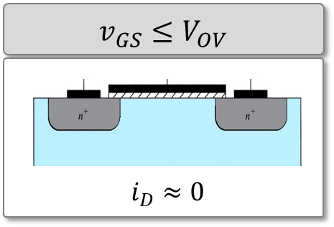
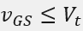
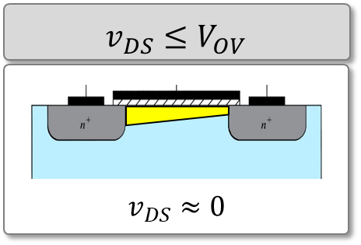

(a) (b)
Figure 5. MOSFET operates under (a) cut-off and (b) triode states

MOSFET datasheet
The MOSFET datasheet can be downloaded from the now learning room (lab 8 MOSFET). They can also be found at the following websites:
https://www.onsemi.com/pdf/datasheet/nds7002a-d.pdf

Procedures:

Output characteristics:
- Connect the circuit as per given diagram shown in Figure 4. Utilize channel 1 of the DC power supply to provide voltage V_{GG} and channel 2 of the DC power supply to provide voltage V_{DD}. Utilize the DMM to measure the drain current by series connection with the resistor R_{D} and drain terminal (positive lead connects to the resistor, negative lead connects to the drain terminal). Use the white “3A” port and right black port for the current measurement. Click on “SHIFT” and then “DCV” to set the DMM to measure current.
- Utilise the channel 1 of the oscilloscope to measure the gate-source voltage (V_{GS}) and channel 2 of the oscilloscope to measure the drain-source voltage (V_{DS}). Note that you will need to adjust the scale of the voltage measurement to be corresponding to the voltage values to be measured (i.e. slightly bigger). The DC voltage can be read by click “Measure”, and then choose “Mean”.
- Keep V_{GS} constant at a value of 1.1 V by varying V_{GG}.
- Vary V_{DS} in step of 1V up to 10 volts and measure the drain current I_{D}. Tabulate all the readings in Table 1 in the results section.
- Repeat the above procedure for V_{GS} as 1.3V, 1.5V.
- Plot the output characteristics V_{DS} vs I_{D}. The horizontal axis should be V_{DS} and the vertical axis I_{D}. There should be one curve for each V_{GS}, namely, the various V_{GS} values generate a family of curves. You should be able to observe on the plot that, for each curve, the current tends to a constant (or, as we say, saturates) as V_{DS} is made large.
Figure 4. Circuit diagram

Transfer characteristics:
- Using the same circuit as above, set the voltage V_{DS} constant at 10 V.
- Vary V_{GS} by varying V_{GG} in the step of 0.1 up to 1.55V and note down value of drain current I_{D}. Tabulate all the readings in Table 2.
- Plot the transfer characteristics V_{GS} vs I_{D}. The horizontal axis should be V_{GS} and the vertical axis I_{D}.
- Calculate V_{T} and g_{m} from the transfer characteristics curve obtained, and calculate r_{o} from the output characteristics curve obtained, verify it from the data sheet.

MOSFET as a switch (Optional):
- Connect the circuit as per given diagram shown in Figure 5. Use a signal generator to provide voltage to the gate.
- Set the signal generator so that It outputs 3.3V square wave with a frequency of 1Hz.
- Observe the response of the LED. Comment on the function this circuit is performing.

Figure 5 Switch circuit

Results:
Table 1 Output characteristics
V_{GS}=1.1V |  | V_{GS}=1.3V |  | V_{GS}=1.5V
V_{DS} (V) | I_{D} (mA) | V_{DS} (V) | I_{D} (mA) | V_{DS} (V) | I_{D} (mA)
1
2
3
4
5
6
7
8
9
10

Table 2 Transfer characteristics
V_{DS}=10V
V_{GS} (V) | I_{D} (mA)
0
0.1
0.2
0.3
0.4
0.5
0.6
0.7
0.8
0.9
1.0
1.1
1.2
1.3
1.4
1.5
1.55

- V_{t}: .
- g_{m}: .
- r_{o}: .
Comment on the function the circuit in Figure 5 is performing:

Post lab Questions:
- To turn on the NMOS, how much voltage is required?
- Why an input characteristic of MOSFET is not drawn?
Answer: Input characteristic means I_{G} vs V_{GS}. However due to the high input impedance of the MOSFET, I_{G}=0.

